War Management 101

1. Maintain a spreadsheet of all standing or active armies and navies, including their locations, compositions, morale and orders. This will allow for easy and quick management of armies.
2. For Grand Strategy:
   * When a war is declared, orders will be given by each player to move their armies into particular provinces. This can and should be limited by distance, unit composition and terrain. For example, a unit may not reach its destination within a turn.
   * When two units occupy the same area/province, they will begin a battle. Each side will be given the composition of the other’s army, and using that information will then form their battle plans as seen in item number 3.
3. For battle automation:
   * Any battle can be feasibly simplified to a number of lines, from front to back line, the successes of which are determined by terrain, technology, morale, numbers and placement.
   * When a battle is going to happen, each involved player will create a formation for their armies in json style. Details will be explained in item 4.
   * For extremely large battles, if necessary, the automation system can be used to determine the outcomes of separate sections of the battle.
   * Attackers and defenders are determined by who controls the territory where the battle is taking place.
4. 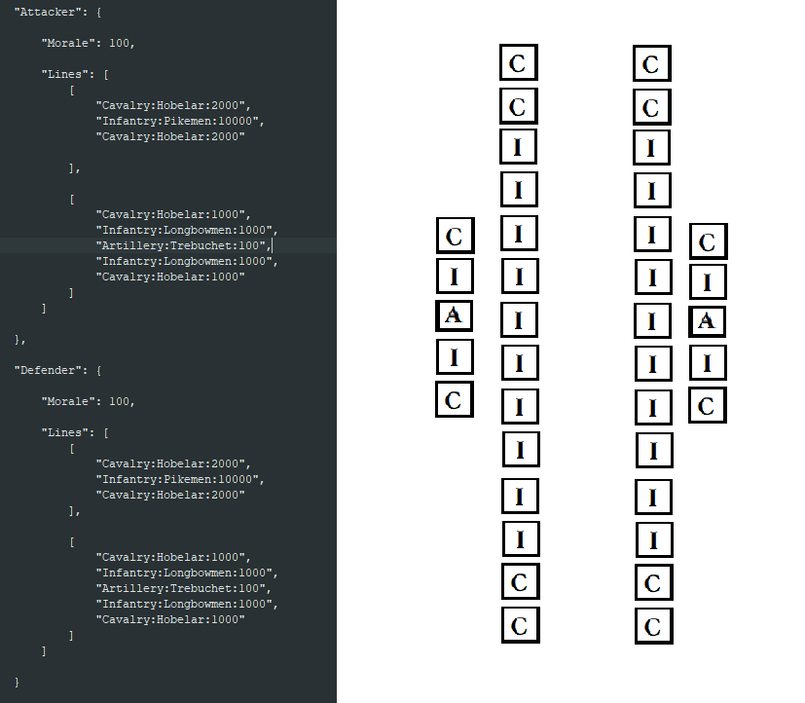 How the program will work:
   * The program reads a file containing the info for the attacking and defending side of a battle. The file will include each side’s lines in terms of infantry, cavalry and artillery.
   * The program splits the line into groups of 1000 for cavalry and infantry, and groups of 100 for artillery. The top line in the formation will be the front line, the bottom line the back line, so on and so forth. Within a line, the top unit will be at the top of the battlefield as shown in the image above.
   * Each unit will attack the closest enemy unit in front of it if it is in range. If one army’s line is smaller than the other, then the other army’s flanks will be able to attack the smaller line’s flanks, dealing extra damage.
   * If combat width is restricted, which it will be for different terrains, then the program will automatically divide each line into smaller lines if it is too big.
   * Importantly, the attacker will always have a slight advantage if all else is equal. This is because their army attacks first and thus their ranged units fire first.
5. For non-battle events:
   * The placement of troops in certain regions can just be filled out on the spreadsheet, disregarding any given tactical justification.
6. For guerrilla warfare/intelligence:
   * In the war spreadsheet, also keep track of intelligence operations, their locations, and if necessary any special tactics. The outcomes of these can easily be decided by either common sense or, if the outcome is too uncertain, dice rolls.